March 23, 2020

To the Board of Directors and Staff
Flexographic Prepress Platemakers Association

Member companies of the AICC, The Independent Packaging Association, and PPC, the Paperboard Packaging Council and the Fibre Box Association (FBA) are among companies clearly identified as essential businesses in the Department of Homeland Security Cybersecurity & Infrastructure Security Agency (CISA) Memorandum on Identification of Essential Critical Infrastructure Workers During COVID-19 Response dated March 19, 2020, attached.

Box manufacturers have increased production to keep packaging flowing to makers of essential products including packaging for food and other consumer products, medical and pharmaceutical products, tissue and hygiene products and more. Boxes are essential to supporting online purchases of goods being delivered directly to homes.

Disruption in the availability of these goods would cause significant hardships to consumers across the country who depend on steady and stable supplies. Box manufacturers are dedicated to continuing the operation of their plants under the guidelines of Center for Disease Control and Prevention (CDC) and the Occupational Safety and Health Administration (OSHA) to ensure products continue to flow to market.

On behalf of the Board of Directors of our two organizations, we need your members to stay open, to the extent possible, as you are critical and essential to the supply chain that keeps us making our essential products.

Sincerely,
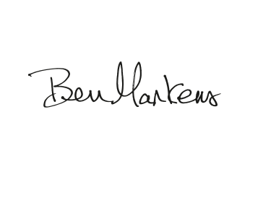

AICC, The Independent
Packaging Association

Michael D’Angelo
President

Paperboard Packaging Council

Bennett Markens
President
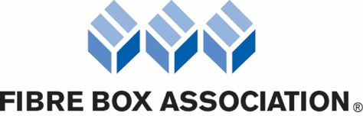

Fibre Box Association

Dennis J. Colley
President & CEO

